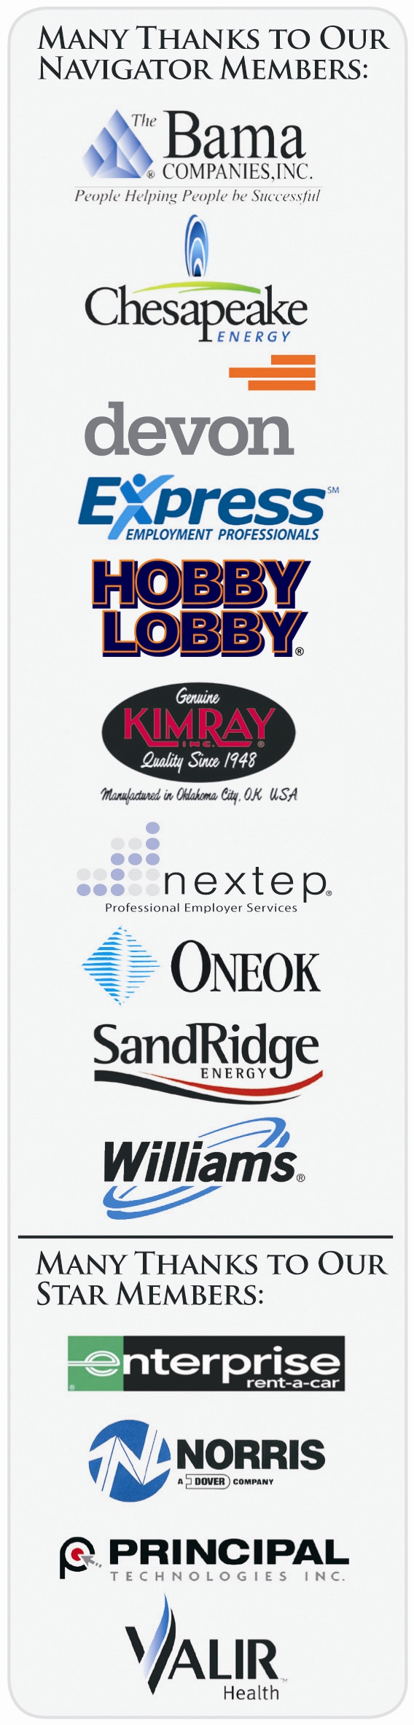
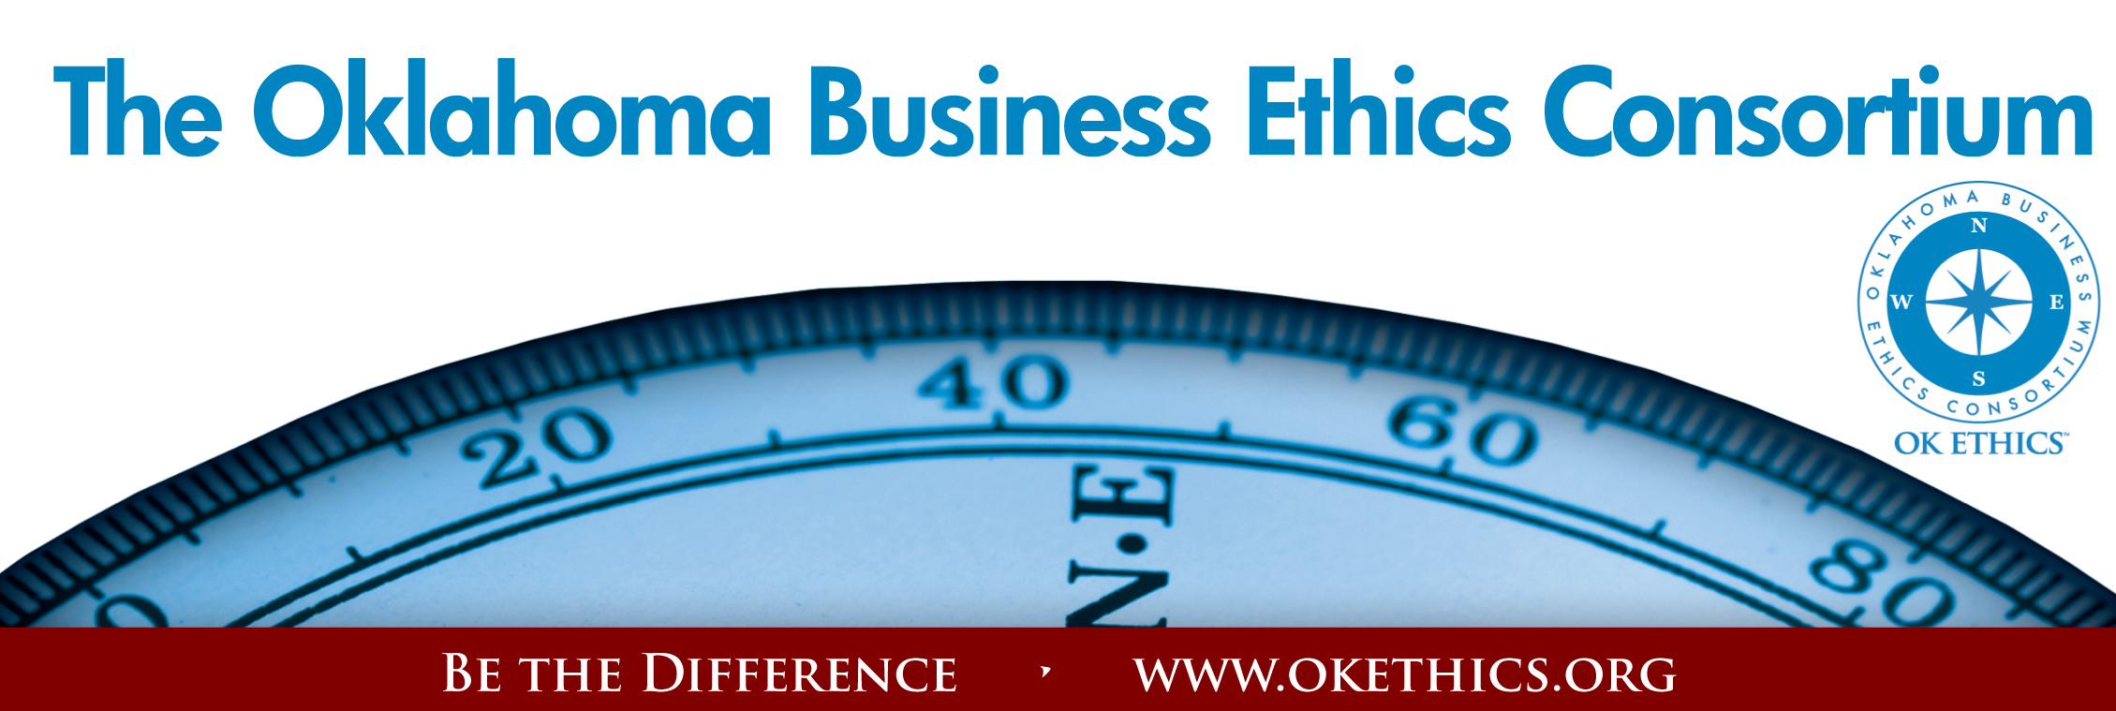
Oklahoma Business Ethics Consortium – June 25, 2009

I. Welcome & Kudos Michael Oonk, Legacy Team &
Membership Co-Chairman

II. Guiding Principal Kevin Kennemer, Legacy Team & Special Projects Coordinator

III. Introduction of our Speaker Lynn Flinn, Legacy Team &
Programs Co-Chairman

IV. Speaker Mark Graham, President & CEO
Tulsa Area United Way

"Leading a Non-Profit Organization
with Integrity in a Recession"

Mark Graham, President and CEO of the Tulsa Area United Way, brings years of volunteer experience with the organization, executive leadership experience, and a passion for the Tulsa Community. A native Tulsan, Mark has more than 25 years of executive experience in the health insurance and banking industries in Tulsa and is active in the community. He is a graduate of the University of Oklahoma.

V. Q&A

VI. Closing remarks Michael Oonk, Legacy Team &
Membership Co-Chairman

Upcoming Meetings
August 24, 2009 Sustainability Panel
September 24, 2009 Chet Cadieux, CEO, QuikTrip

Many thanks to our volunteers and Legacy team members for making this and every other meeting possible: Carol Swarthout, Lynn Flinn, John Stancavage, Michael Oonk, Whitney Mathews, Jan Laub, Jenny Lizama, Jennifer Lyon, Tom Clatfelter, David White, Shere Rockwell, Kevin Kennemer, Kari Culp, Royce Kelly and Nick Minden.

General Disclaimer: Members of the Oklahoma Business Ethics Consortium frequently share information concerning various issues and developments that may have legal implications. The discussions, commentary, and handouts at Consortium meetings or presentations to other organizations are for general informational purposes only. They cover only some aspects of the subject topic, and do not constitute a complete legal analysis of the topic or how it might apply to any particular set of facts. Before taking any action based on information presented during a Consortium event, participants are encouraged to consult a qualified attorney.
The observations and comments of presenters at Consortium meetings and networking are the views and opinions of the presenter and do not constitute the opinion or policies of the Consortium or any of its members. Presenters are respectfully requested to avoid profanity, preaching, politics and self-promotion during their lectures.

